Document#1: Documentation Requirements
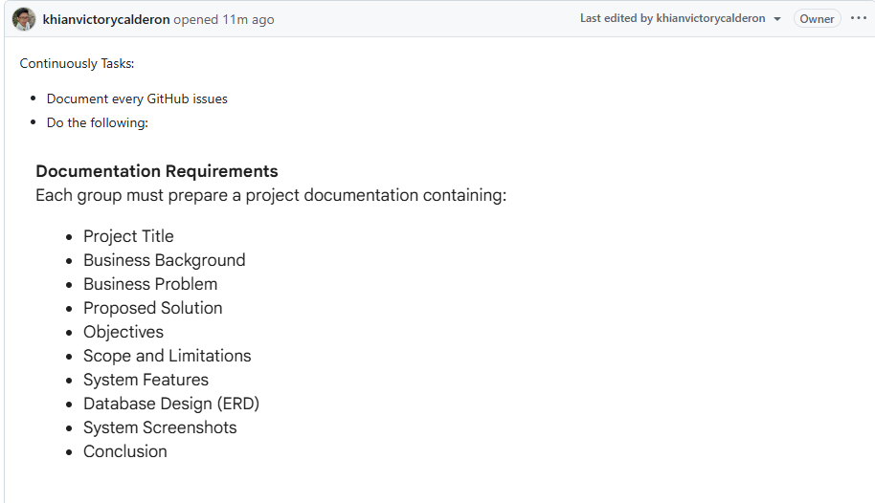
Description: This day, our team starts documenting the project. Every GitHub issue needs documentation attached. Each group prepares one project document with ten sections. Include the project title, business background, the problem we’re solving, our proposed solution, objectives, scope and limitations, system features, database design as an ERD, system screenshots, and a conclusion, this document becomes our project’s foundation.

Document#2: Landing Page and Its Components
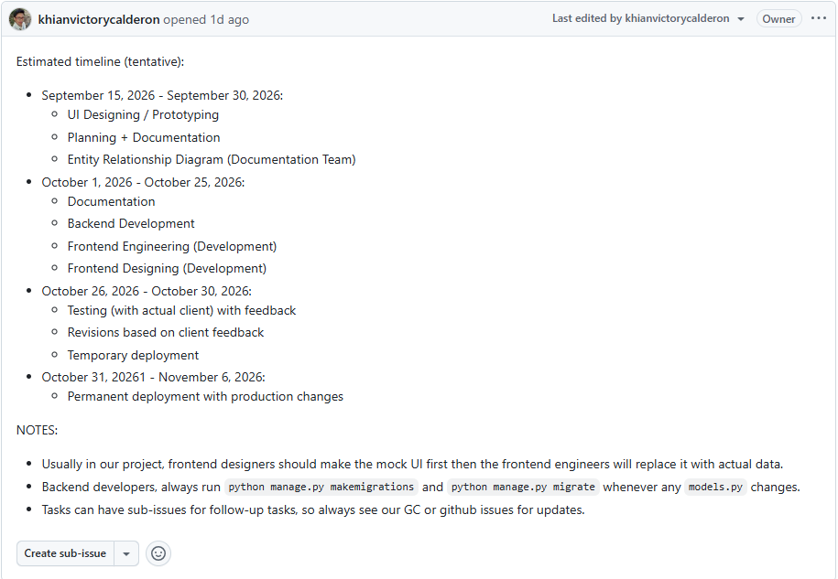
Description: This day, our team maps out of four phases over seven weeks. From September 15 to 30, it focuses on UI design, prototyping, planning, and documentation. From October 1 to 25, it covers the backend development and frontend work. From October 26 to 30, it includes the testing with the actual client and revisions. From October 31 to November 6, it launches the product to live servers. Designers will build mockups first. Engineers will replace them with real data. Backend developers will run migrations whenever the data model changes.

Document#3: Project Timeline
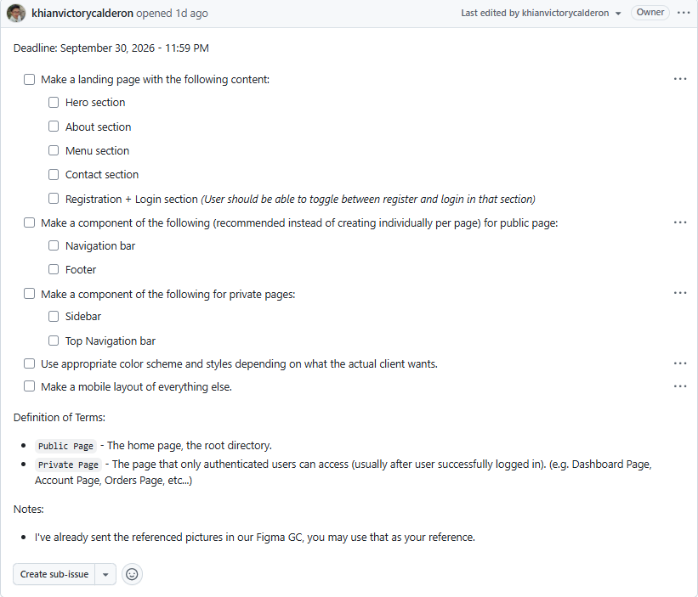
Description: This day, our team builds the landing page by September 30 at 11:59 P.M. We created a page with five sections: hero, about, menu, contact, and a registration/login toggle. We also build reusable components for the whole site. Public pages share a navigation bar and footer. Private pages (for logged-in users) share a sidebar and top navigation bar. Everything follows the client’s color scheme and works on mobile devices.

